The Colonial Williamsburg Foundation
P.O. Box 1776
Williamsburg, VA 23187-1776
www.colonialwilliamsburg.com

Special Savings on Tickets, Accommodations for Homeschoolers Feb. 22-March 1

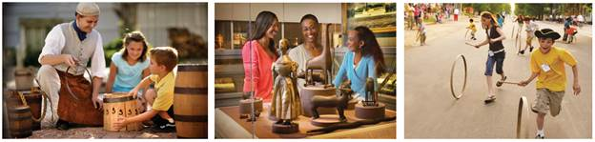

WILLIAMSBURG, Va. – (Feb. 20, 2020) Colonial Williamsburg’s Spring Homeschool Days offer homeschoolers special deals on admission, interactive program experiences and accommodations to immerse families in the 18th century, Feb. 22-March 1.

Single-day and Multiday admission tickets for homeschoolers are available during Spring Homeschool Days at more than 70 percent off retail. Tickets provide access to Colonial Williamsburg’s Historic Area exhibition buildings, gardens and trades sites and the world-class Art Museums of Colonial Williamsburg – the DeWitt Wallace Decorative Arts Museum and the Abby Aldrich Rockefeller Folk Art Museum – which remain open throughout their $41.7-million, 650,000 square-foot expansion, funded entirely through donor support and scheduled for completion this year.

Visits can be tailored to include on-site dining, 18th century-style tavern meals, evening entertainment and lodging. Homeschool Days ticket holders qualify for special rates on Colonial Houses, the Griffin Hotel and at the Williamsburg Woodlands Hotel & Suites.

Spring Homeschool Days ticketed activities include opportunities to explore science, technology, engineering, art and math (STEAM) subjects through the historic trades, live the life of a militia soldier, discover rare-breeds livestock, meet 18th-century Nation Builders and more.

To receive the Homeschool Days discount, tickets must be purchased in advance online by visiting colonialwilliamsburg.com/homeschoolers. All sales are final. Special rates are available year-round for homeschool groups of all sizes in addition to a wide variety of books, DVDs and other teaching resources.

To reserve accommodations at a Colonial Williamsburg hotel, or for more information visit colonialwilliamsburghotels.com/packages/homeschool.

Additional information is available by calling 800-228-8878 toll-free, by emailing groupsales@cwf.org, and by following Colonial Williamsburg on Facebook and @colonialwmsburg onTwitter and Instagram.

Media contact: Joe Straw
757-220-7287
jstraw@cwf.org

The Colonial Williamsburg Foundation preserves, restores and operates Virginia’s 18th-century capital of Williamsburg. Innovative and interactive experiences highlight the relevance of the American Revolution to contemporary life and the importance of an informed, active citizenry. The Colonial Williamsburg experience includes more than 600 restored or reconstructed original buildings, renowned museums of decorative arts and folk art, extensive educational outreach programs for students and teachers, lodging, culinary options from historic taverns to casual or elegant dining, the Golden Horseshoe Golf Club featuring 45 holes designed by Robert Trent Jones and his son Rees Jones, a full-service spa and fitness center, pools, retail stores and gardens. Philanthropic support and revenue from admissions, products and hospitality operations sustain Colonial Williamsburg’s educational programs and preservation initiatives.
– CWF –

