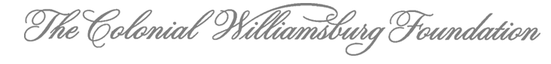

Use the IRA Charitable Rollover to Support
Colonial Williamsburg Foundation
Tax ID #: 54-0505888

If you are 70½ or older, you can make a tax-free distribution from your traditional or Roth IRA to Colonial Williamsburg, known as an IRA Qualified Charitable Distribution (QCD) or IRA Charitable Rollover. Benefits include:

- The IRA rollover amount is excluded from your taxable income.
- You may roll over up to $100,000 every year from your IRA as a QCD.
- If you are age 73 or older, the QCD can also count towards your required minimum distribution (RMD).
- New for 2023: You may establish a charitable gift annuity with Colonial Williamsburg of up to $50,000 (limited to only one tax year during your lifetime).

Making Your IRA Gift

To make an IRA QCD gift to Colonial Williamsburg, please direct your IRA administrator to mail a check payable to “The Colonial Williamsburg Foundation” to the address below:
The Colonial Williamsburg Foundation
Attn: Special Gifts Administrator
P.O. Box 1776
Williamsburg, VA 23187-1776

IMPORTANT:
- Instruct your IRA administrator to include your name on IRA QCD check.
- Alert Colonial Williamsburg by contacting Margaret McGraw, Special Gifts Administrator, at (757) 565-8605 or mmcgraw@cwf.org before making an IRA QCD gift, so that we may identify and acknowledge your gift promptly.

NOTE: If you are still working and contributing to your IRA, an IRA QCD gift could impact your taxable income. If you are under age 70 ½, you can still use your IRA to support Colonial Williamsburg by making a withdrawal and donating the proceeds after taxes, or by designating Colonial Williamsburg as a beneficiary of your IRA.

Please consult a qualified advisor before making an IRA gift.

